Lab 1 Computer Systems

Nguyen Nam Tung 103181157

|  |  |  |
| --- | --- | --- |
| Pin 1 | Pin 2 | Output |
| 1 | 0 | 0 |
| 0 | 1 | 0 |
| 0 | 0 | 0 |
| 1 | 1 | 1 |

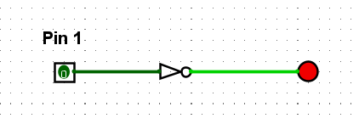

|  |  |
| --- | --- |
| Pin 1 | Output |
| 0 | 1 |
| 1 | 0 |

|  |  |  |
| --- | --- | --- |
| Pin 1 | Pin 2 | Output |
| 1 | 0 | 1 |
| 0 | 1 | 1 |
| 0 | 0 | 1 |
| 1 | 1 | 0 |

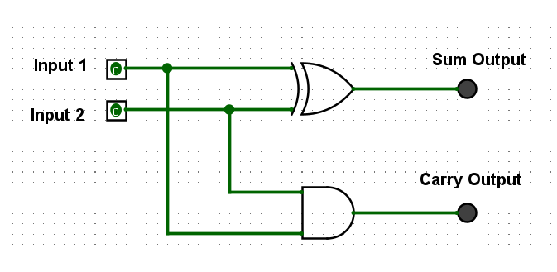

|  |  |  |  |
| --- | --- | --- | --- |
| Input 1 | Input 2 | Sum Output | Carry Output |
| 1 | 0 | 1 | 0 |
| 0 | 1 | 1 | 0 |
| 0 | 0 | 0 | 0 |
| 1 | 1 | 0 | 1 |

|  |  |  |  |  |
| --- | --- | --- | --- | --- |
| Input 1 | Input 2 | Carry in | Sum Output | Carry Output |
| 0 | 0 | 0 | 0 | 0 |
| 0 | 1 | 0 | 1 | 0 |
| 1 | 0 | 0 | 1 | 0 |
| 1 | 1 | 0 | 0 | 1 |
| 0 | 0 | 1 | 1 | 0 |
| 0 | 1 | 1 | 0 | 1 |
| 1 | 0 | 1 | 0 | 1 |
| 1 | 1 | 1 | 1 | 1 |